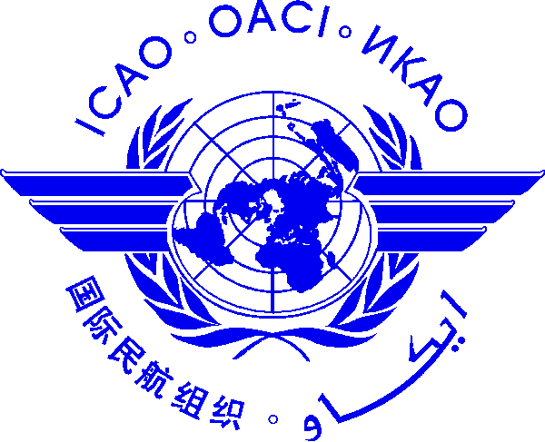 |  | International Civil Aviation Organization  Cooperative Development of Operational Safety and Continuing Airworthiness Programme (COSCAP) South East Asia  Training Program for Government Safety Inspectors  ICAO Asia and Pacific Office, Bangkok, Thailand  [ ] Auditing Techniques and Practices for Aviation Regulators: 6-10 Feb 2017  [ ] AOC and Surveillance for Airworthiness Inspectors: 20-24 Feb 2017  [ ] AOC and Surveillance for Flight Operations Inspectors: 13-17 March 2017  [ ] Fundamental of Personnel Licensing (PEL): 15-19 May 2017  Please choose one course per each participant and register by: 27 January 2017

Nomination Form [please type or print]

State/ Organization
Name | Title |  | Family name (capitals) | First name | Middle initial
□ Mr.:
□ Ms.:
□ Mrs.:
□ Other:
Designation
Mailing Address
Telephone (office)
Fax
(office)
E-mail
Hotel in Bangkok
Date

NOTE: Participants are expected to make their own hotel and visa arrangements.

After completing, please send to:
COSCAP-SEA Programme Secretary
E-mail: khun.nong@coscap-icao.org
Fax International: +66 2 287 0805

